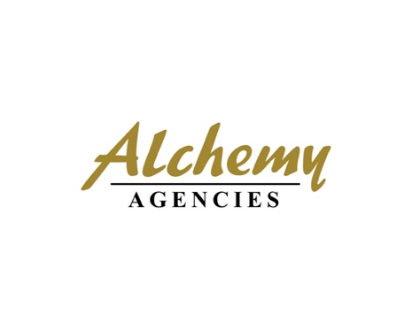

27th May 2025

**PRESS RELEASE**

**Arla Foods Ingredients and Alchemy Agencies**

**sign new distribution agreement**

Arla Foods Ingredients and Alchemy Agencies have announced a new distribution partnership to serve the performance nutrition market in Australia, New Zealand and the Pacific Islands.

Effective immediately, the distribution agreement will primarily focus on Australia and New Zealand (ANZ). It supports Arla Foods Ingredients’ strategy to expand sales in Southeast Asia and in ANZ/Oceania, where Alchemy Agencies is a leading distributor of speciality food and beverage ingredients.

The new agreement covers five key brands in Arla Foods Ingredients’ range of premium performance nutrition ingredients:

* Lacprodan® whey protein isolate, which contains at least 90% protein and offers solutions for ready-to-drink (RTD) sports beverages, gels, powder shakes and protein bars
* Capolac®, a milk mineral concentrate rich in highly bioavailable calcium, magnesium and phosphorus, with benefits for muscle function, healthy bones and body composition
* MicelPure®, a micellar casein isolate containing 86% native protein and naturally high in calcium for sports nutrition RTD beverages and shakes
* Nutrilac® PB-8420, a high-quality whey and milk protein ingredient that ensures soft texture, processability and robustness for the outer mass of sports protein bars
* Nutrilac® MFGM, which is rich in high-quality whey protein and the complex lipids present in milk fat globule membrane to support physical performance and strength

The ANZ region has the second highest per capita global spend on sports nutrition products, including bars, drinks and powder shakes, and Australia is the world’s third largest sports nutrition market.[1]

Alexander Leufgen, Head of Asia-Pacific at Arla Foods Ingredients, said: “Arla Foods Ingredients is delighted to welcome Alchemy Agencies as a distribution partner. The new agreement for ANZ/Oceania is an excellent fit for our performance nutrition solutions in this dynamic market. Crucially, it will play a key role in supporting our ambitions in Asia-Pacific and ensuring our focus on customer centricity and service.”

Tristan Molloy, director of Alchemy Agencies, said: “We are very excited to bring our expertise in gaining sales and creating strong brand value to Arla Foods Ingredients’ performance nutrition ingredients in ANZ/Oceania. The new agreement aligns with our expansion plans for our partner and supplier network and strengthens our involvement in the fast-growing sports nutrition market across our key regions.”

**For more information contact:**

Richard Clarke, Ingredient Communications

Tel: + +44 (0) 7766 256176| Email: [richard@ingredientcommunications.com](mailto:richard@ingredientcommunications.com)

**About Arla Foods Ingredients**  
Arla Foods Ingredients is a global leader in improving premium nutrition. Together with our customers, research partners, suppliers, NGOs and others, we discover and deliver documented ingredients and products that can advance lifelong nutrition for the benefit of consumers around the world.

We serve leading global brands in early life nutrition, medical nutrition, sports nutrition, health foods, and other foods and beverages.

Five reasons to choose us:

* We’re passionate about improving nutrition
* We innovate by connecting the best
* We master both discovery and delivery
* We build strong, long-lasting partnerships
* We are committed to sustainability

Headquartered in Denmark, Arla Foods Ingredients is a 100% owned subsidiary of Arla Foods.

<https://www.arlafoodsingredients.com/>

**LinkedIn**

<http://www.linkedin.com/company/arla-foods-ingredients>

**LinkedIn (Latin America)**

<https://www.linkedin.com/showcase/arla-foods-ingredients-latin-america/>

**LinkedIn (China)**

https://www.linkedin.com/showcase/arla-foods-ingredients-china/

**About Alchemy Agencies**

Alchemy Agencies is an employee owned company that has supplied to the Australian, New Zealand and Pacific Islands food and beverage market since 1996. Alchemy is a team of respected industry professionals that are committed to bringing innovative products to the market, and partner with customers and suppliers to develop unique and novel products that offer a point of difference. Technical advice, flexibility and speed of response are key attributes. For more information, visit: <https://alchemyagencies.com>

1. Euromonitor, 2025